Case 1: When Vote pod is deleted

The voting app functionality is unchanged even when i deleted vote pod .

The reason being the replica set takes care of creating new pod in place of deleted one.

Replica set created a new vote pod when I deleted the pod (see the age for created time difference)

Case 2 : When Worker Pod is deleted

The voting app functionality is unchanged even when i deleted Worker pod as the data is not stored in worker pod itself

But the logs stored in the pod are lost when the pod is deleted as they are stored in the pod itself.

Case 3 : When DB pod is deleted

The voting app functionality is changed not showing the latest data in the web page(resulting app)

The resulting app pod not able to connect to the new db pod as it is still connected to deleted DB.

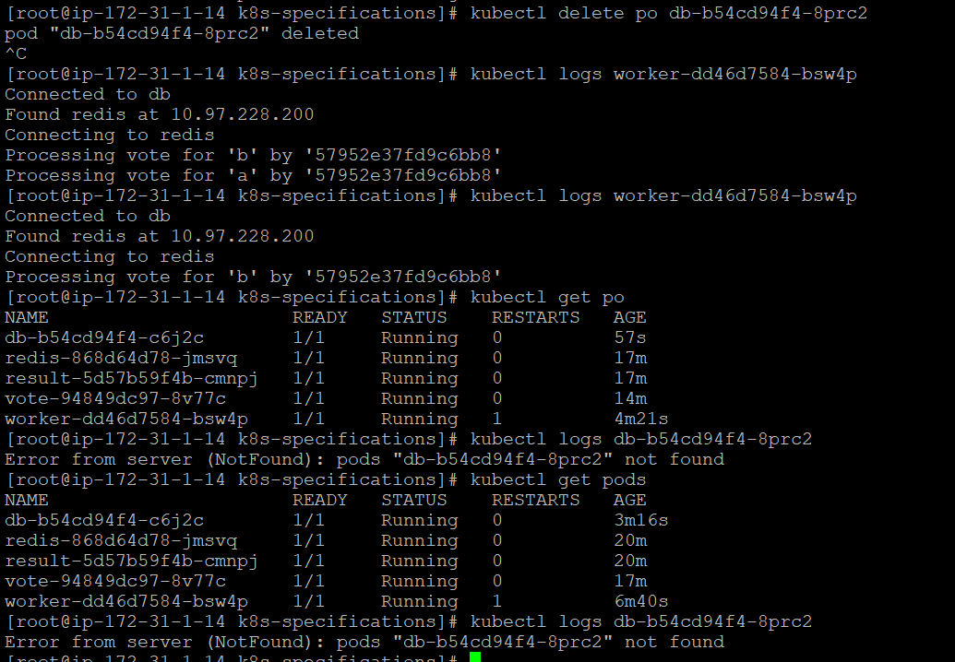

To resolve the issue we can delete the result pod so that it can be created again and connect it to the new DB pod.s